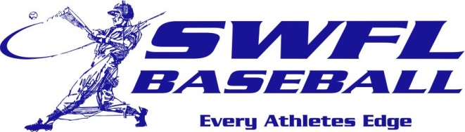

Southwest Florida Baseball is proud of the players that have worked to earn a scholarship and the opportunity to continue their baseball career. Congratulations to these players that have excelled in the classroom and on the field. Best of luck men!

2018 commitments:

Brandt Sundean Florida Gulf Coast U
Carson King Florida Southern
Warnner Rincones Broward College
Matt Cedarburg College of Central Florida
Tyler Prell FSC – Jacksonville
Thomas Joseph Florida Southwestern St
Jackson Spiller St. John’s River St.
Collin Camarigg Florida Southern College
Matt Jolley Santa Fe State
Jake Curry Polk State
Josh Collett Seminole State
Nick Vanderhoef Barry U
Austin Blair FSC – Jacksonville
Jackson Ross Pasco Hernando State
Damian Lusby Maryville U
Danny Cunnigham Barry U
Connor Berry Pasco Hernando State
Sean Osceola Pasco Hernando State

