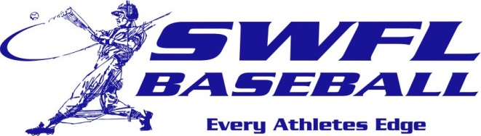

Southwest Florida Baseball is proud of the players that have worked to earn a scholarship and the opportunity to continue their baseball career. Congratulations to these players that have excelled in the classroom and on the field. Best of luck men!

2017 commitments: School

Robb Adams Virginia U
David Mata Bethune Cookman
Gio Lorenzo Bethune Cookman
CJ Schrowe Florida SouthWestern St.
Trent Sinkfield Polk State
Alec Babb Oglethorpe U
Drew Dwyer Indian River St.
Cole Brutcher Indian River St.
Trey Frazier Flagler College
Matt Lepoint Army
Kevin Long FSC – Jacksonville
Forest Thuene Florida SouthWestern St.
Alex Perez Ave Maria U
Joey Mugavero Florida SouthWestern St.

