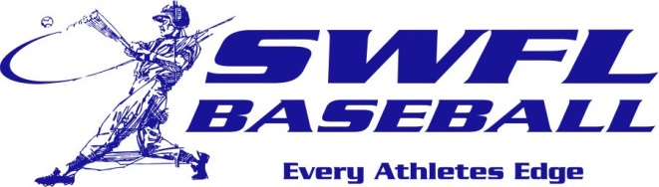
Southwest Florida Baseball is proud of the players that have worked to earn a scholarship and the opportunity to continue their baseball career. Congratulations to these players that have excelled in the classroom and on the field. Best of luck men!

2016 commitments:
Anthony Churlin U Central Florida – signed Oak 16th
BJ Minarcin Rollins College
Josh Winckowski FSW – signed TOR 15th
Devyn White Nova SEU
Justin Mason Indian River St
John D’Amelio Stetson U
Justin Hartshorne Ave Maria U
Blake Roxberry Ave Maria U
Sam Mieses Lake Sumter St
Mason Dineson Ave Maria U/West Florida U
Matt Ranson Lenoir Rhyne U
Max McKettrick Warner U
Will Nelson Warner U
Michael Richey Ball State/Tallahassee CC

