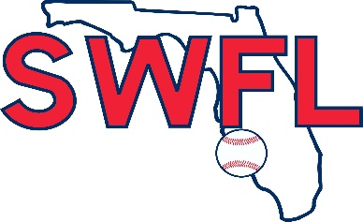 Skarbek-Saez SWFL Summer Invitational June 1-2, 2019
Terry Park Sports Complex ~3410 Palm Beach Blvd, Fort Myers, FL 33916

14U POOL 1 14U POOL 2 9. SWFL RED 17. SWFL 2021
1. SWFL 14 5. WAVE 10. SWFL UPPERCLASS 18. SWFL 2022
2. SWFL 13 6. EAGLES 14 11. PRO BOUND 19. SWFL TAMPA BLUE 16
3. TURN TWO 14 7. TURN TWO 13 12. BASEBALL EXPRESS 20. SWFL SOUTHRIDGE 16
4. BLACK TIPS 8. FUSION 13. SWFL SOUTHRIDGE 18 21. BATS 16
14. SWFL TAMPA RED 18 22. EAGLES 16
COIN TOSS FOR HOME TEAM 15. BOMBERS 23. BLACK SOX
16. SWFL UNDERCLASS 24. FLORIDA 9 HARDBALL
FRI 6pm FIELD 4
23 VS 24
SAT FIELD 1-Stadium FIELD 2 FIELD 3 FIELD 4
8am 9 VS 12 5 VS 6 7 VS 8 2 VS 3
10:15 10 VS 12 1 VS 4 6 VS 8 5 VS 7
12:30 9 VS 10 3 VS 4 1 VS 2 11 VS 13
2:45 15 VS 17 19 VS 20 16 VS 21 13 VS 14
5pm 15 VS 18 22 VS 20 16 VS 19 11 VS 14
SUN FIELD 1-Stadium FIELD 2 FIELD 3 FIELD 4
8am 5 VS 8 1 VS 3 12 VS 14 15 VS 19
10:15 6 VS 7 2 VS 4 9 VS 11 16 VS 20
12:30 14u CHAMPIONSHIP 17 VS 18 10 VS 13 21 VS 22
2:45pm 21 VS 18 24 VS 22 23 VS 17

*$5.00 Admission per day - 12 under are free *NO cooler in any Lee County Parks facilities
*Run rule- (14u)- 10 after 4, 8 after 5 *Run rule-(16u-18u) – H.S. Rules
*No new inning after 2 hours *16u-18u Wood Bats only
*Follow us on Twitter: @SWFL Baseball

