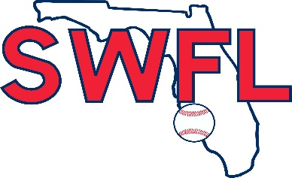 SWFL Fall Invitational September 21-22, 2019
Terry Park Sports Complex ~3410 Palm Beach Blvd, Fort Myers, FL 33916

1. OBA 5. IDA BAKER
2. SWFL 2020 6. MIAMI SOUTHRIDGE
3. SWFL UPPERCLASS 7. Fort Myers FUSION
4. SWFL 16u 8. FORT MYERS HS
9. RIVERDALE HS

COIN TOSS FOR HOME TEAM

SAT FIELD 1-Stadium FIELD 2 FIELD 4
9am 5 VS 3 7 VS 4 --------
11:30 5 VS 6 7 VS 4 1 VS 2

SUN FIELD 1-Stadium FIELD 2 FIELD 4 FIELD 3
9am 5 VS 4 1 VS 2 -------- 6 VS 3
11:30 7 VS 8 1 VS 3 6 VS 2 9 VS 4

*$5.00 Admission per day - 12 under are free *NO coolers in any Lee County Parks facilities
*Run rule – H.S. Rules
*No new inning after 2 hours
*Wood Bats only- Optional for 16u JV teams
*Follow us on Twitter: @SWFLBaseball

