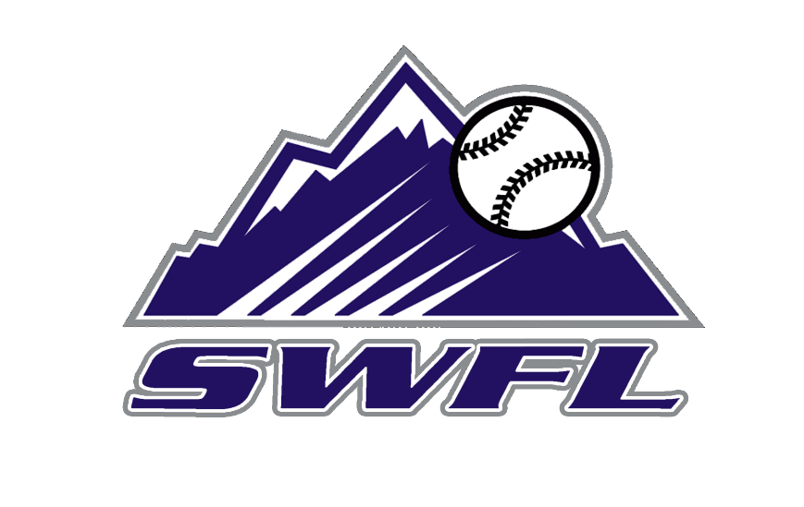
2028 SWFL Rockies Scout team schedule

May Event Location
18 SWFL Baseball Bash and BBQ Island Coast HS
30-31 PG BCS Qualifier Fort Myers, FL

June
1-2 PG BCS Qualifier Fort Myers, FL
13-16 PG City of Palms Classic Fort Myers, FL
19-22 PBT Florida Open Bradenton, FL

July
5-7 PG Freedom Classic Fort Myers, FL
10-14 PG 15U BCS Fort Myers, FL
19-23 Prospect Wire Nationals Sarasota, FL

Coaches:
Billy Printz
Andrew Davino

