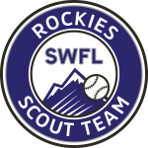

2027 SWFL Rockies Fall schedule

September

6 Ostinger’s Baseball (DH) Fort Myers
13 – 14 USF Team Camp Tampa, FL
19 – 21 Prospect Select World Series West Palm Beach, FL
27 – 28 Stetson U Team Camp Deland, FL

October

4 PG WWBA World Championships Fort Myers, FL

