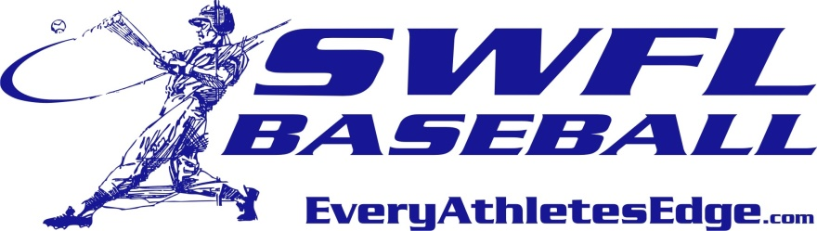

SWFL Baseball 2016 Fall Invitational

- SWFL 2017 11. SWFL 2019/Sabre Cat
- Nations Goodrich 12. Ostinger’s 16U
- Hit Factory 18U 13. West Coast 9-16U
- Ostinger’s 18U 14. Hit Factory-16U
- SWFL 2018 15. SWFL 2020
- Nations Rags 16. Sticks N Seams
- Nations Morgan 17. SWFL 16U
- Brooksville 18. Xtreme Baseball16U
- West Coast 9- 18U 19. Hit Factory Upper Class
- SWFL 18U 20. Canes

SAT |  | Player Development
 | Field 1 | Field 2 | Field 3 | Field 4 | Field 5
9:00 | 19 V 20 | 1 V 4 | 2 V 5 | 9 V 7 | 17 V 18
11:30 | 9 V 8 | 3 V 1 | 4 V 5 | 18 V 16 | 7 V 10
2:00 | 6 V 8 | 3 V 2 | 12 V 11 | 14 V 13 | 15 V 16
SUN |  | Player Development
 | Field 1 | Field 2 | Field 3 | Field 4 | Field 5
9:00 | 15 V 17 | 19 V 9 | 1 V 2 | 7 V 8 | 12 V 14
11:30 | 20 V 6 | 16 V 17 | 15 V 18 | 12 V 13 | 11 V 14
2:00 |  | 11 V 13 | 6 V 4 | 5 V 19 | 20 V 3

Development Complex: 4301 Edison Ave, Fort Myers, FL 33916
Daily admission: $5 ~ 12 under are free. Lee County prohibits coolers in parks.
Invitational game guidelines:
- Wood bats only, 7 inning games, 2 hour time limit, no new inning after 2 hours.
- 10 run rule after 6 innings unless agreed upon by both coaches for less innings.
- Coin flip for home team

